43.39: a) 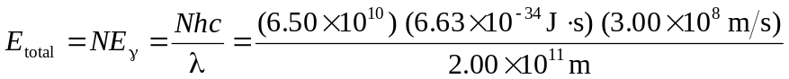
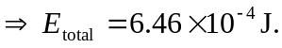

b) The absorbed dose is the energy divided by tissue mass:
` 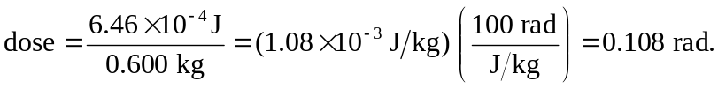
The rem dose for x rays (RBE = 1) is just 0.108 rem.

